
WorkSheet -10
Student Name: Arnab Lala UID: 25MCI10232
Branch: M.C.A(A.l & M.L) Section/Group: MAM-1 A
Semester: Sem -2 Date of Performance: 21-04-2026
Subject Name: TECHINCAL SKILLS Subject Code: 25CAP-652
AIM:
To understand and apply transaction control in PostgreSQL using BEGIN, COMMIT, ROLLBACK, and SAVEPOINT to maintain data integrity during database operations.
S/W Requirement: PostgreSQL and pgAdmin
OBJECTIVES:
Apply transaction control commands for safe and reliable database updates. Practical / Experiment Steps
Table creation:
DROP TABLE IF EXISTS Payroll; CREATE TABLE Payroll ( emp_id INT PRIMARY KEY, emp_name VARCHAR(50), salary DECIMAL(10,2) CHECK (salary > 0)
);
INSERT INTO Payroll VALUES
(1, 'Amit', 30000),
(2, 'Neha', 40000),
(3, 'Ravi', 50000);
SELECT * FROM Payroll;

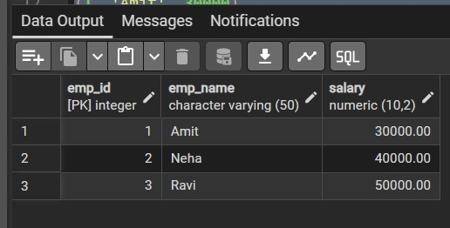
Figure 1: Table created and initial data inserted

Experiment 1: Transaction with ROLLBACK
BEGIN;
UPDATE Payroll
SET salary = -1000
WHERE emp_id = 3;
SELECT * FROM Payroll;
ROLLBACK;
SELECT * FROM Payroll;

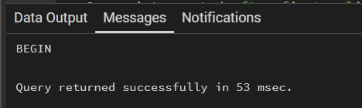
Figure 2: Transaction started with BEGIN

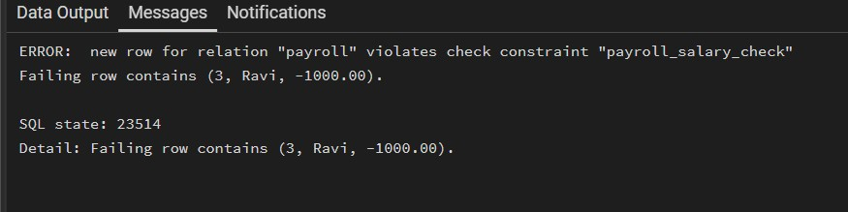
Figure 3: Constraint violation error during update

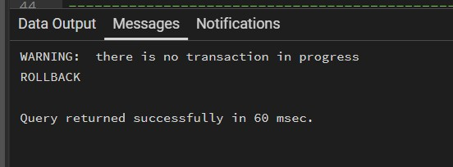
Figure 4: Table state after rollback

Experiment 2: Transaction with SAVEPOINT
BEGIN;
UPDATE Payroll
SET salary = salary + 5000
WHERE emp_id = 1;
SAVEPOINT sp1;
UPDATE Payroll
SET salary = salary + 7000
WHERE emp_id = 2;
UPDATE Payroll
SET salary = -1000
WHERE emp_id = 3;
ROLLBACK TO sp1;
COMMIT;
SELECT * FROM Payroll;

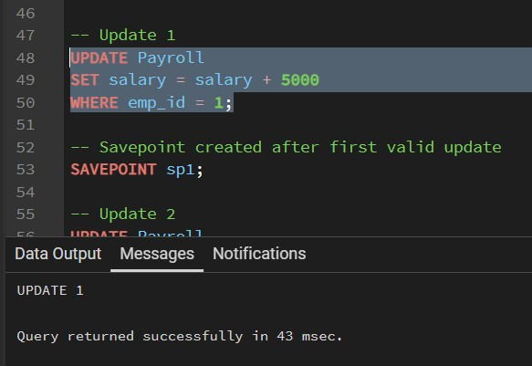
Figure 5: First valid update before savepoint

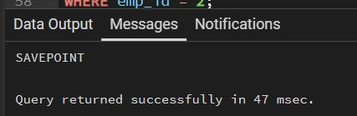
Figure 6: Savepoint created successfully

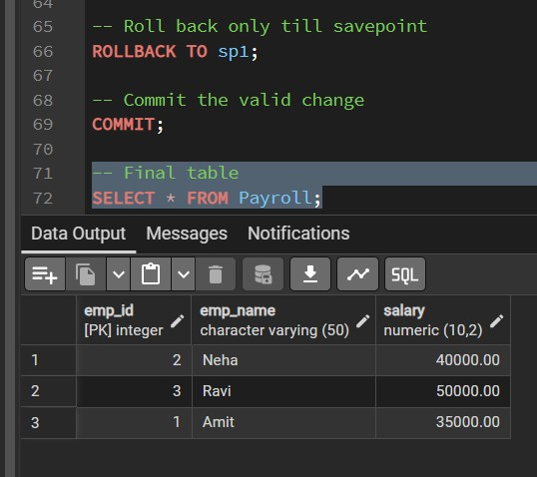
Figure 7: Final result after rollback to savepoint and commit

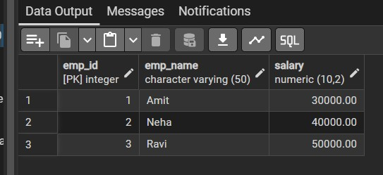
Figure 8: Table data after transaction handling
Outcomes:
- BEGIN starts a transaction block for grouping multiple SQL commands.
- ROLLBACK cancels changes made inside the transaction.
- SAVEPOINT allows partial rollback without losing all valid updates.
- CHECK constraint ensures salary remains greater than zero.
- PostgreSQL transaction control helps maintain consistency and data integrity.

